 

**AIRLINE DATA ANALYTICS FOR AVAITION INDUSTRY**

NALAIYA THIRAN PROJECT BASED LEARNING ON PROFESSIONAL

READLINESS FOR INNOVATION, EMPLOYNMENT AND ENTERPRENEURSHIP

**A PROJECT REPORT**

**RAGAVI R**

**VARSHA R**

**BIMLA V M**

**AZHAGUMATHI G**

**BANNARI AMMAN INSTITUTE OF TECHNOLOGY**

**TEAM ID : PNT2022TMID02023**

FACULTY MENTORS NAME : V.SRI VINITHA

**INDUSRTY MENTORS NAME** : MOHAMMED AZHAR UDDIN

**TABLE OF CONTENTS**

1. **INTRODUCTION** 
   1. Project Overview
   2. Purpose
2. **LITERATURE SURVEY** 
   1. Existing problem
   2. References
   3. Problem Statement Definition
3. **IDEATION & PROPOSED SOLUTION** 
   1. Empathy Map Canvas
   2. Ideation & Brainstorming
   3. Proposed Solution
   4. Problem Solution fit
4. **REQUIREMENT ANALYSIS** 
   1. Functional requirement
   2. Non-Functional requirements
5. **PROJECT DESIGN** 
   1. Data Flow Diagrams
   2. Solution & Technical Architecture
   3. User Stories
6. **PROJECT PLANNING & SCHEDULING** 
   1. Sprint Planning & Estimation
   2. Sprint Delivery Schedule
   3. Reports from JIRA
7. **CODING & SOLUTIONING (Explain the features added in the project along with code)** 
   1. Feature 1
   2. Feature 2
   3. Database Schema (if Applicable)
8. **TESTING** 
   1. Test Cases
   2. User Acceptance Testing
9. **RESULTS** 
   1. Performance Metrics
10. **ADVANTAGES & DISADVANTAGES**
11. **CONCLUSION**
12. **FUTURE SCOPE 13. APPENDIX** Source Code

GitHub & Project Demo Link

**AIRLINE DATA ANALYTICS FOR AVAITION INDUSTRY**

**1.INTRODUCTION**

**1.1Project Overview** :

* + - Users create multiple analytical graphs/charts/Visualizations.
    - Using the Analytical Visualizations, build the required Dashboard(s).
    - Saving and visualizing the final dashboard in the IBM Cognos Analytics.

**1.2 PURPOSE**

To provide better Airline and AirPort services and to avoid delays in Air Travel across different locations at Municipality level. The aim is to provide airports, airlines, and the travelling public with a neutral, third-party view of which airlines are delivering on their promise to get passengers from Point A to Point B on-time.

**2.LITERATURE SURVEY :**

* 1. **Existing problem :**

The airport codes may refer to either the IATA airport code, a three-letter code that is used in passenger reservation, ticketing and baggage-handling systems, or the ICAO airport code which is a four-letter code used by ATC systems and for airports that do not have an IATA airport code.

* 1. **References :**

1.Data Science And Analytics In Aviation(2020): Authors:Sai-Ho-Chung,Hoi-Lam-ma

2.Data Analytics for Air Travel Data(2021): Authors:Haiman Tian,Yudong Tao

1. Topological Data Analysis For Aviation Applications(2018): Authors: Max Z. Li,Megan S. Ryerson and Hamsa Balakrishnan

1. Operational Efficiency Versus Financial Mobility In The Global Airline Industry(2015): Author:Hoi-Lam-ma

1. An Evaluation Of The Operational Performance And Profitability Of The

U.S. Airlines(2021): Author:Emillio Collar

**2.3 Problem Statement Definition :**

To identify and manage many people traveling this summer, they are noticing first –hand that airlines are facing major challenges, including numerous flight cancellations and delays.

**3.IDEATION & PROPOSED SOLUTION :**

**3.1Empathy Map Canvas:**

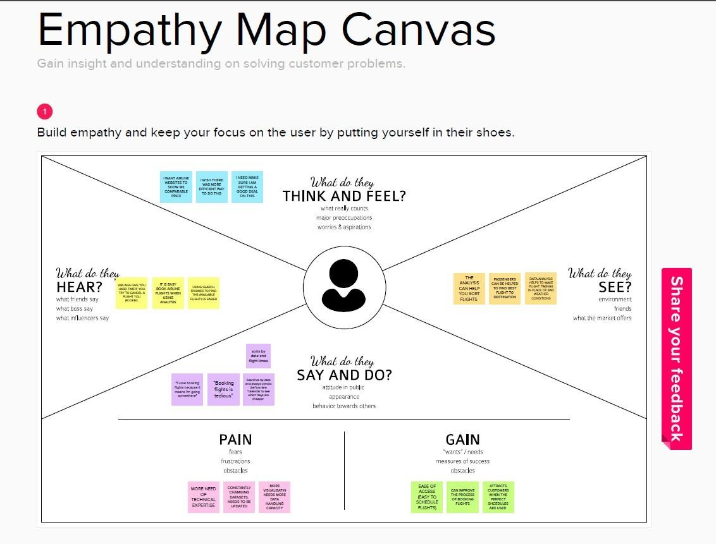

**3.2 Ideation & Brainstorming :**

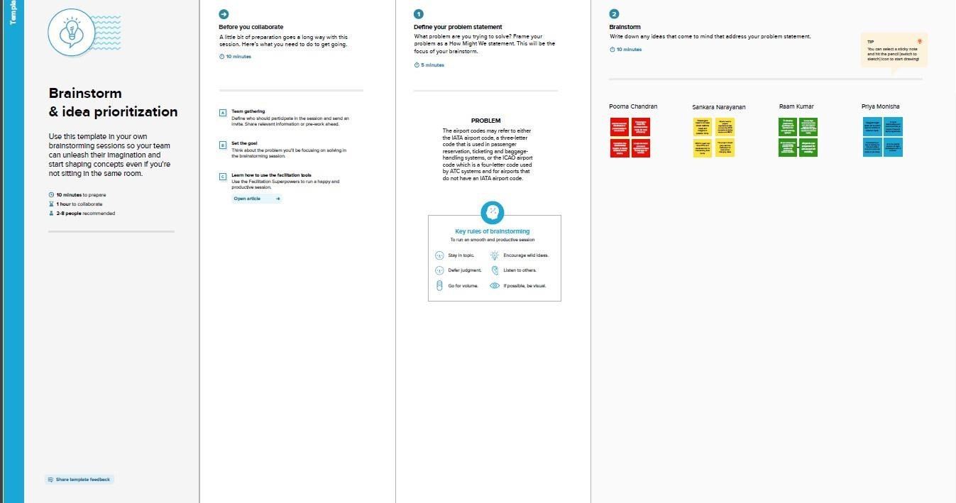

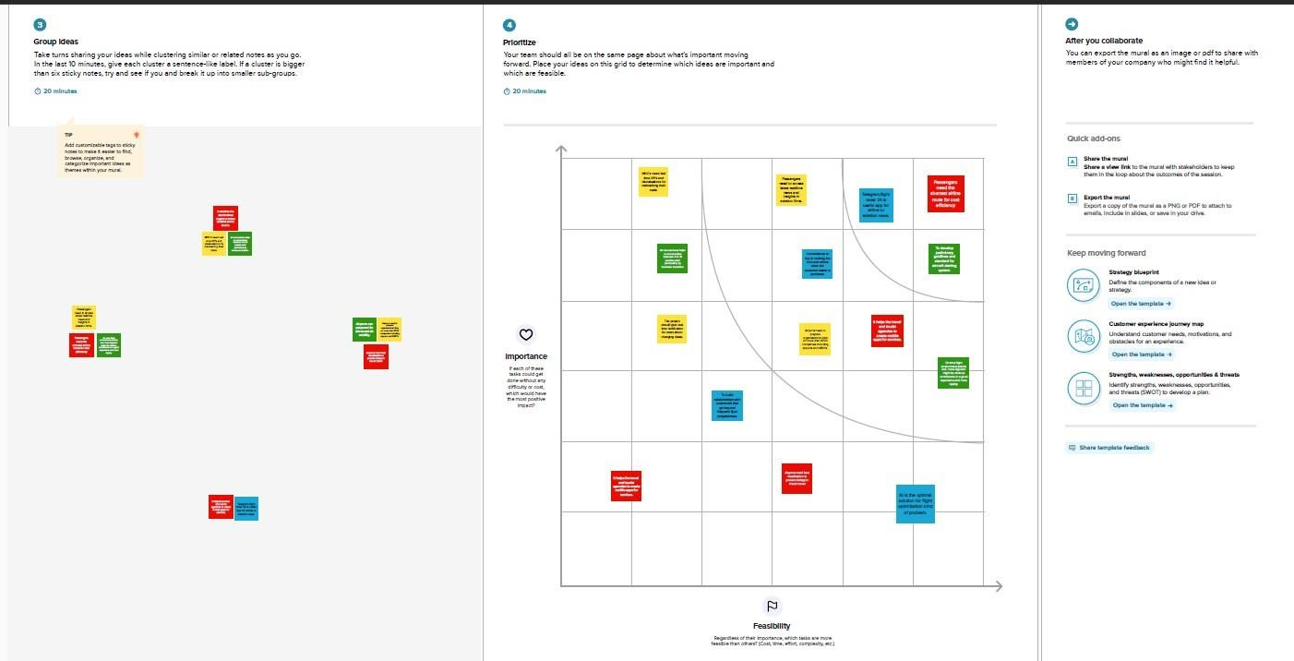

**3.3Proposed Solution :**

|  |  |  |
| --- | --- | --- |
| **S.No.** | **Parameter** | **Description** |
| **1.** | Problem Statement  (Problem to be solved) | ❖ With the growing demand for air transportation and the limited ability to increase capacity at some key points in the air transportation system, there are concerns that in the future the system will not scale to meet demand.This situation will result in the generation and the propagation of delays throughout the system, impacting passengers’ quality of travel and more broadly the economy. |
| **2.** | Idea / Solution description | * Understanding traveler demand for specific city pairs and pricing flights can be done using data analytics project. * Airlines use this biometric technology as a boarding option. The equipment scans travelers’ faces and matches them with photos stored in border control agency databases. These can be handled with the aforementioned project. |
| **3.** | Novelty / Uniqueness | ❖ The ultimate benefits of big data analytics include timely responses to current and future market demands, improved planning and strategically aligned decision making, as |

|  |  |  |
| --- | --- | --- |
|  |  | well as crystal clear comprehension and monitoring of all main performance drivers relevant to the airline industry.  ❖ Due to the use of smart data analytics, passengers will avoid many issues with baggage tracking. While radio-frequency identification prevents mishandling the baggage, predictive analysis assists in improving the predictability of fleet reliability. |
| **4.** | Social Impact / Customer  Satisfaction | ❖ Data analytics helps the industry to understand customers’ preferences and other maintenance issues. ❖ For instance, analysis of ticket booking helps the industry to target the customers with personalized offers while optimizing the price in real- time using predictive analysis techniques. As a result, by gathering meaningful data, airlines can fetch more bookings in the given timeframe. |
| **5.** | Business Model (Revenue  Model) | * Business models   innovation in airlines can contribute to the creation of value, competitive advantage and profitability with new possibilities of action.   * A revenue model is a |

|  |  |  |
| --- | --- | --- |
|  |  | blueprint that shows how a startup business will earn revenue or gross income from its standard business operations, and how it will pay for operating costs and expenses. |
| **6.** | Scalability of the Solution | ❖ The Cloud Cognos  Analytics is not only for particular organization/governments. ❖ Aviation industry acting under international, domestic or private are also getting satisfied with the aviation data analyzing process provided as per their needs. |

**3.4Problem Solution fit :**

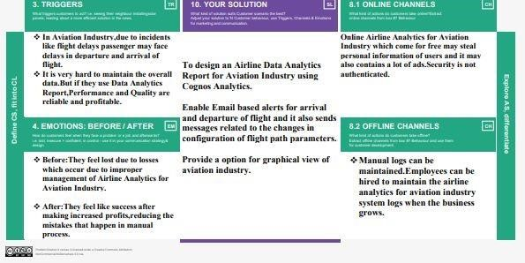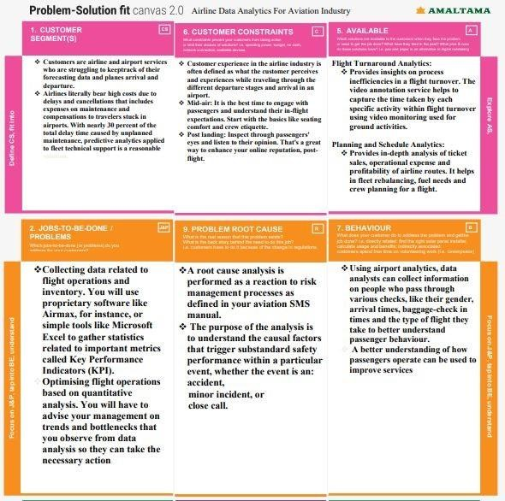

**4.REQUIREMENT ANALYSIS :**

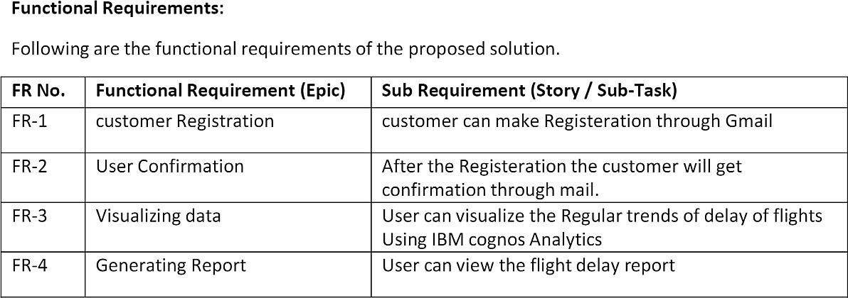

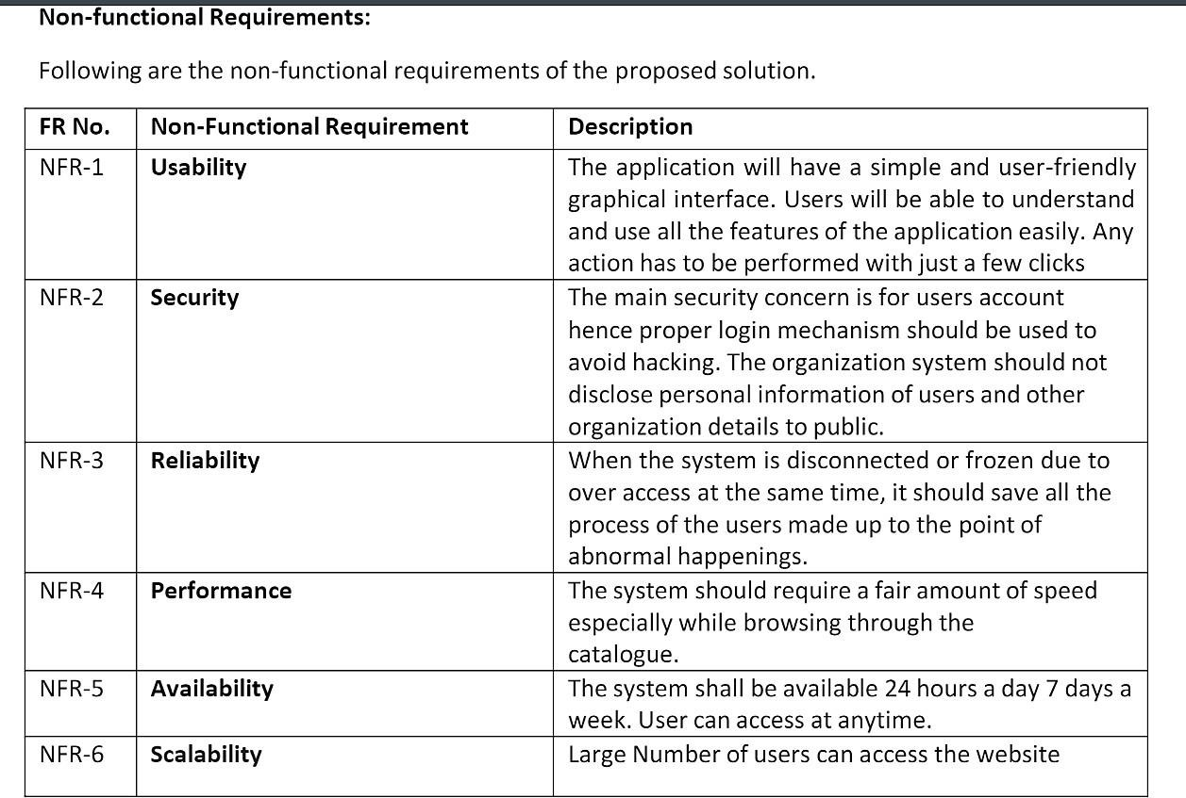

**5.PROJECT DESIGN:**

* 1. **Data Flow Diagrams:**

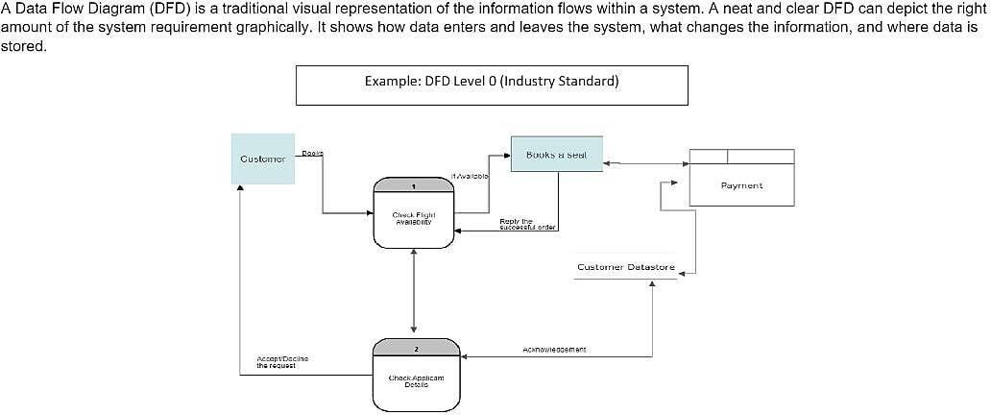

* 1. **Solution & Technical Architecture :**

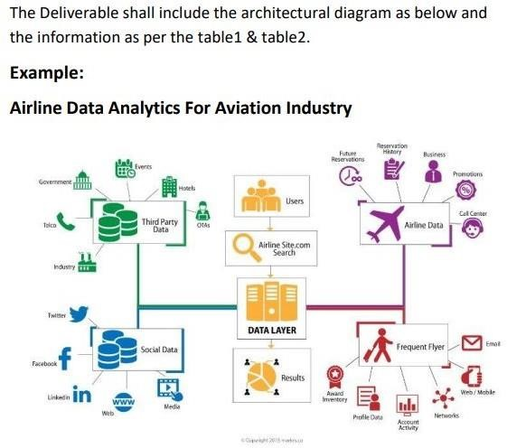

**5.3**

**User**

**Stories**

**:**

**6.**

**PROJECT**

**PLANNING**

**&**

**SCHEDULING:**

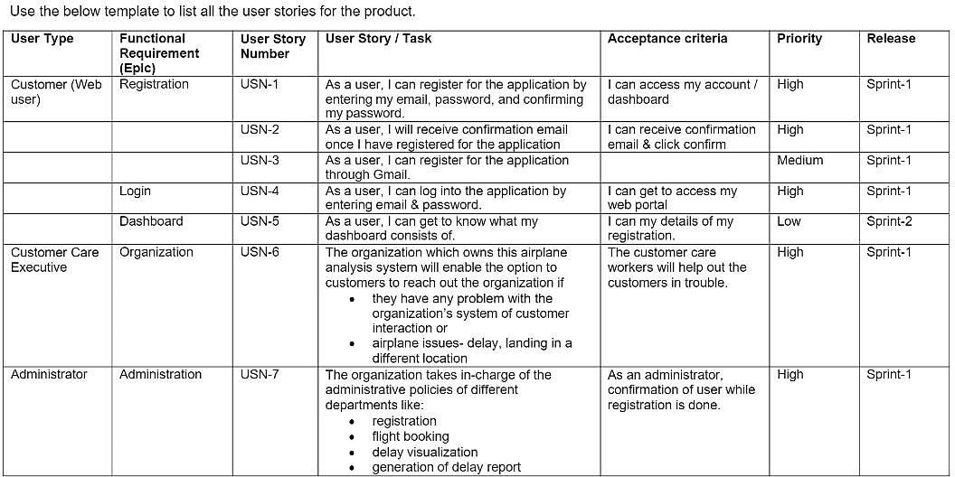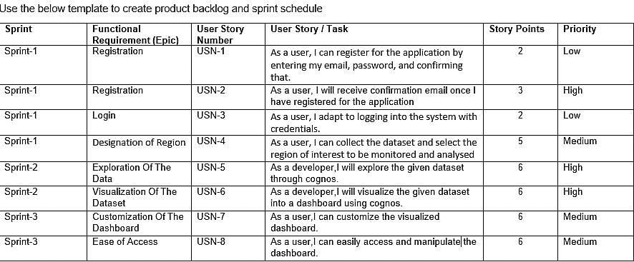

**6.1Sprint Planning & Estimation:**

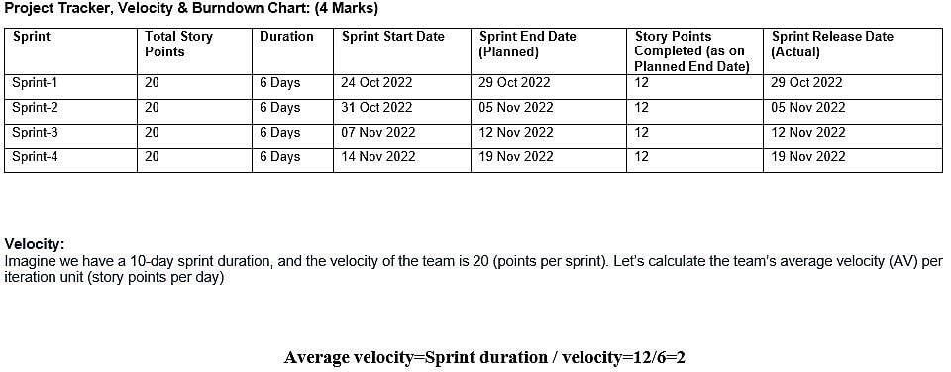

**6.2Sprint Delivery Schedule :**

A milestone schedule, or milestone chart, is a timeline that uses milestones to divide a project schedule into major phases. A milestone chart is a way to visualize the most important steps of our project. Each milestone the team achieves brings us closer to completing the project. As a result, milestones provide a sense of accomplishment and show the team how the work they’re doing contributes to the overarching project objective.

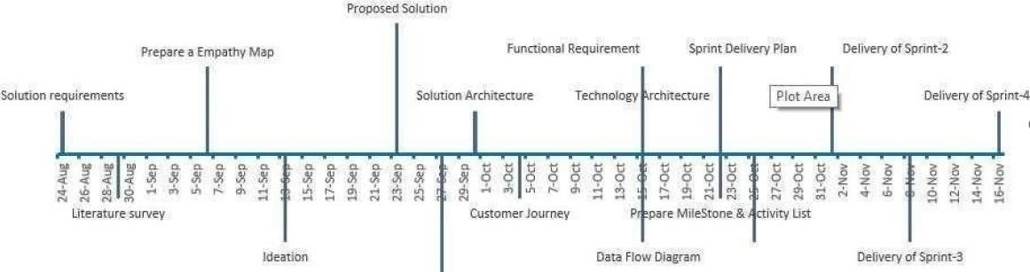

**6.3Reports from JIRA :**

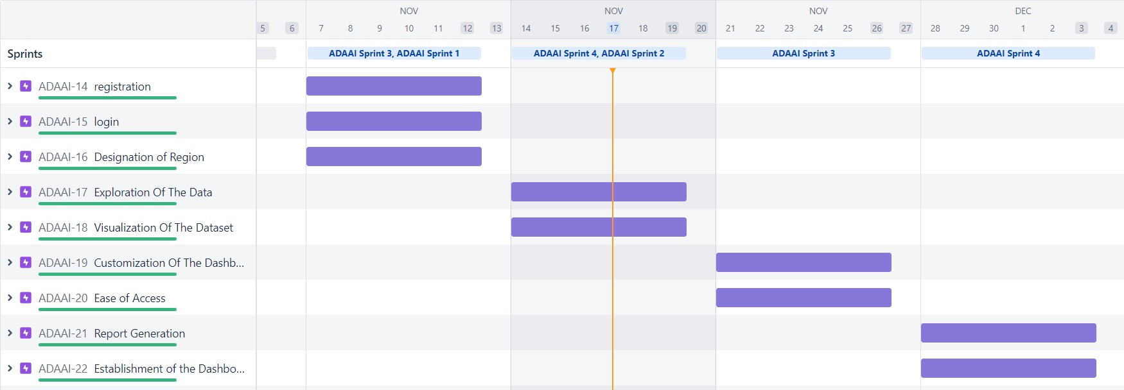

**7.WORKING WITH THE DATASETS AND DATA VISUALISATION :**

**Working With The Dataset :**

* Understand the Dataset
* Load the Dataset
* Perform Joins of the Dataset tables

**Understanding The Dataset :**

The data can be downloaded from the Links :

1. [AirStats data on airports around the world](https://www.kaggle.com/patrasaurabh/airstats-data-on-airports-around-the-world)
2. [Circum - Airport Performance Reports](https://www.cirium.com/studios/on-time-performance/)
3. [Resources Coverage data](https://www.flightstats.com/v2/resources/coverage-data)  ● Airports.csv

|  |  |  |
| --- | --- | --- |
| # | Field Name | Data Type |
| 1 | id | Int |
| 2 | ident | Text |
| 3 | type | Text |
| 4 | name | Text |
| 5 | latitude_deg | Geo |
| 6 | longitude_deg | Geo |
| 7 | elevation_ft | int |
| 8 | continent | Text |
| 9 | iso_country | Text |
| 10 | iso_region | Text |
| 11 | municipality | Text |
| 12 | scheduled_servi ce | Boolean |
| 13 | gps_code | Text |
| 14 | iata_code | Text |
| 15 | local_code | Text |
| 16 | home_link | Text |
| 17 | wikipedia_link | Text |
| 18 | keywords | Text |

* Countries.csv

|  |  |  |
| --- | --- | --- |
| # | Field Name | Type |
| 1 | id | Int |
| 2 | code | Text |
| 3 | name | Text |
| 4 | continent | Text |
| 5 | wikipedia_link | Text |
| 6 | keywords | Text |

* Regions.csv

|  |  |  |
| --- | --- | --- |
| # | Field Name | Type |
| 1 | id | Int |
| 2 | code | Text |
| 3 | local_code | Text |
| 4 | name | Text |
| 5 | continent | Text |
| 6 | iso_country | Text |
| 7 | wikipedia_li nk | Text |
| 8 | keywords | Text |

**DATASET LINK:**

<https://www.kaggle.com/patrasaurabh/airstats-data-on-airports-around-the-world>

**Loading Of Dataset**

Before you build a view and analyze your data, you must first connect the data to IBM Cognos.

Cognos supports connecting to a wide variety of data, stored in a variety of places.

The data might be stored on your computer in a spreadsheet or a text file, or in a big data, relational, or cube (multidimensional) database on a server in your enterprise.

In our case, we will be using a spreadsheet or text file for making our analysis.

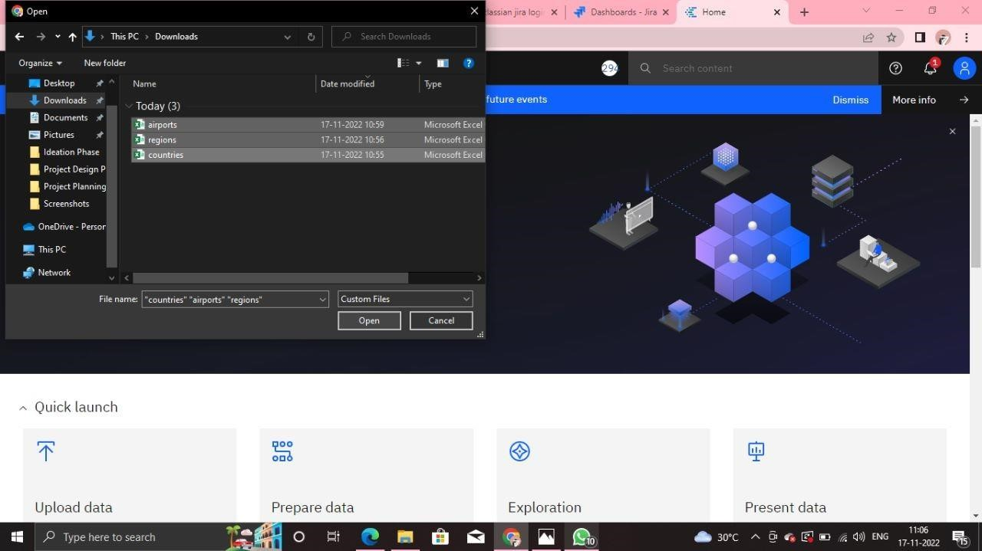

**Data Preparation :**

Data Preparation.

- Validate all the tables - airports, countries, regions - Create calculated field - Continent Name using the codes.

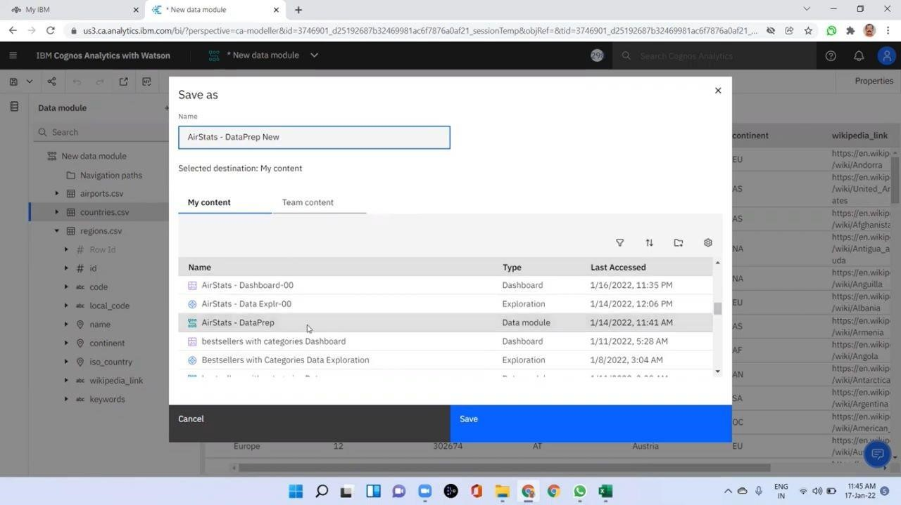

**Joining Of Tables :**

Joining of Tables Airports, Countries and Regions with the related columns.

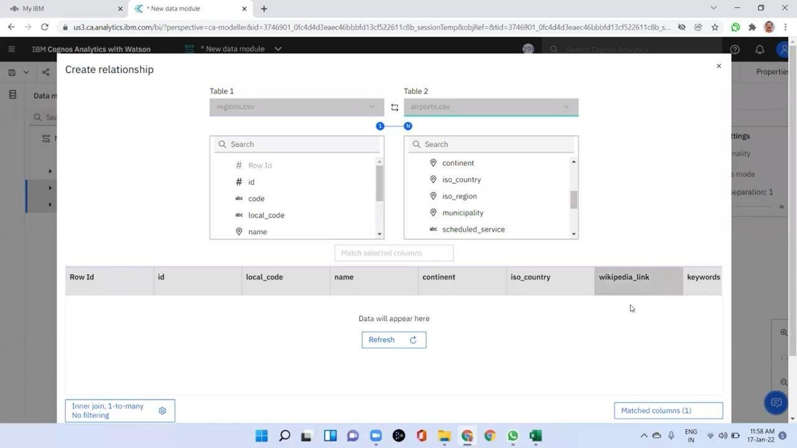

**Exploration Of Data :**

* Explore from data directly or via an existing asset in a Dashboard or Story.
* Leverage advanced analytics in an accessible way, opening the door for any user to surface compelling new insights.
* Interact with contextual recommendations that guide users to greater understanding of their data.
* Start exploring immediately with an intuitive, natural language tool that lowers the barriers to entry for the world of analytics.

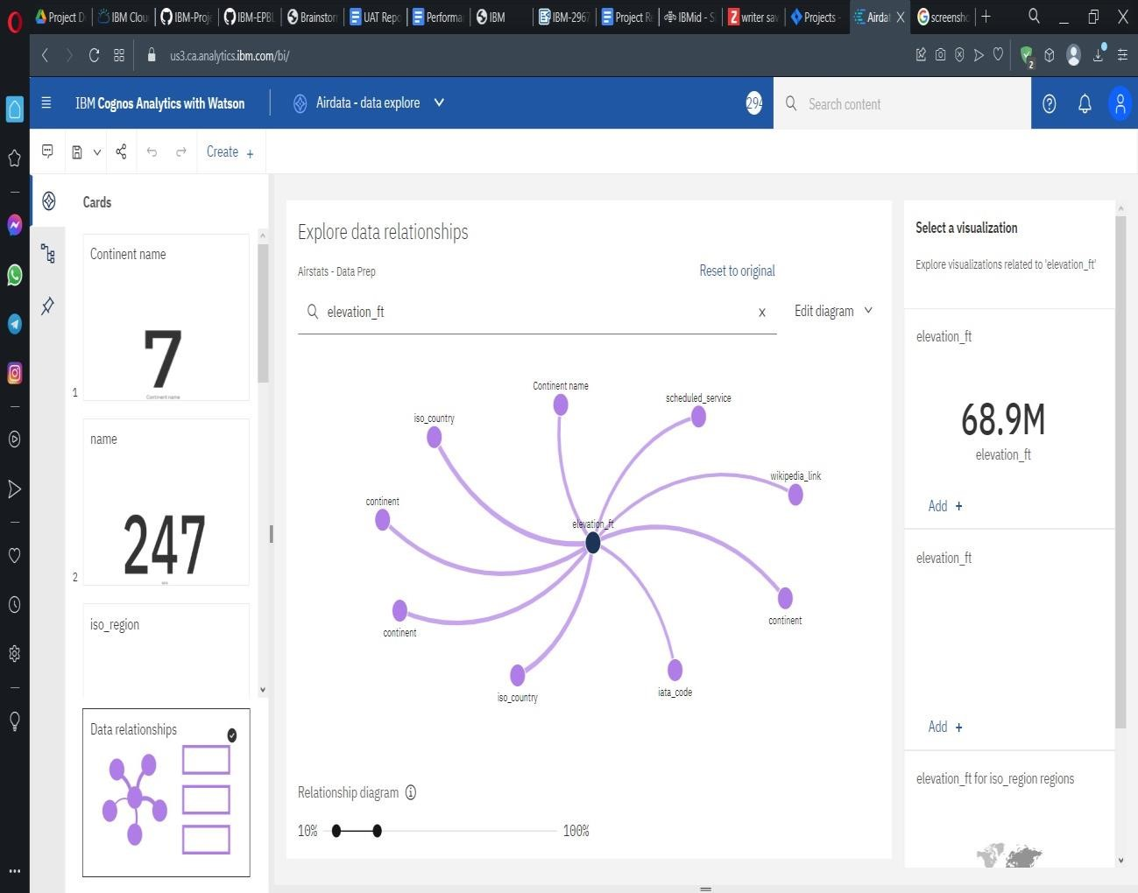

**Data Visualization :**

Using the given dataset, we plan to create various graphs and charts to highlight the insights and visualizations.

**Representation Of Flight Count By Categories :**

Representation of Flight Count by Categories.

1. Pie Chart - Continent-wise No. of Flights.
2. Packed Bubble Chart - Continent wise No. of Flights by Type - Colored with Type. 3.Continent List - Filter.

4.Top 10 Countries by Flights.

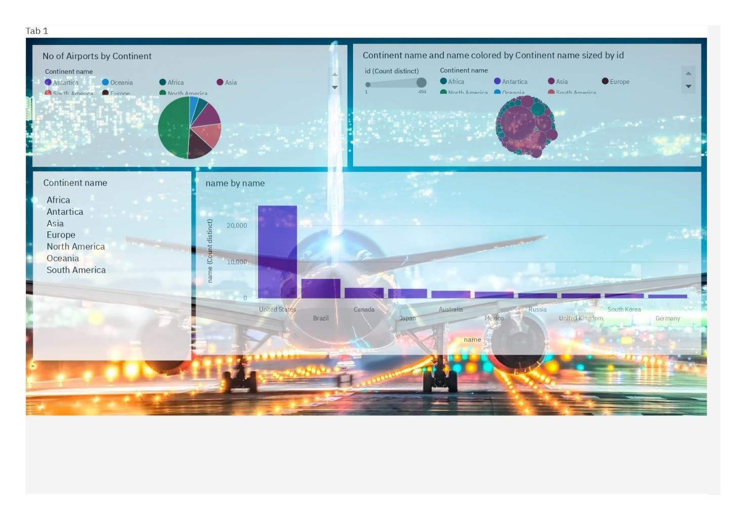

**No Of Flights By Countries , Regions And Airports :**

1. Build the Summary Cards showing the

- Number of Countries, Number of distinct Regions, Number of Airports and Number of Municipalities

1. Build the number of Airports by Countries using a Column Chart
2. Build a Waterfall-Chart showing the number of Airports by Continents.

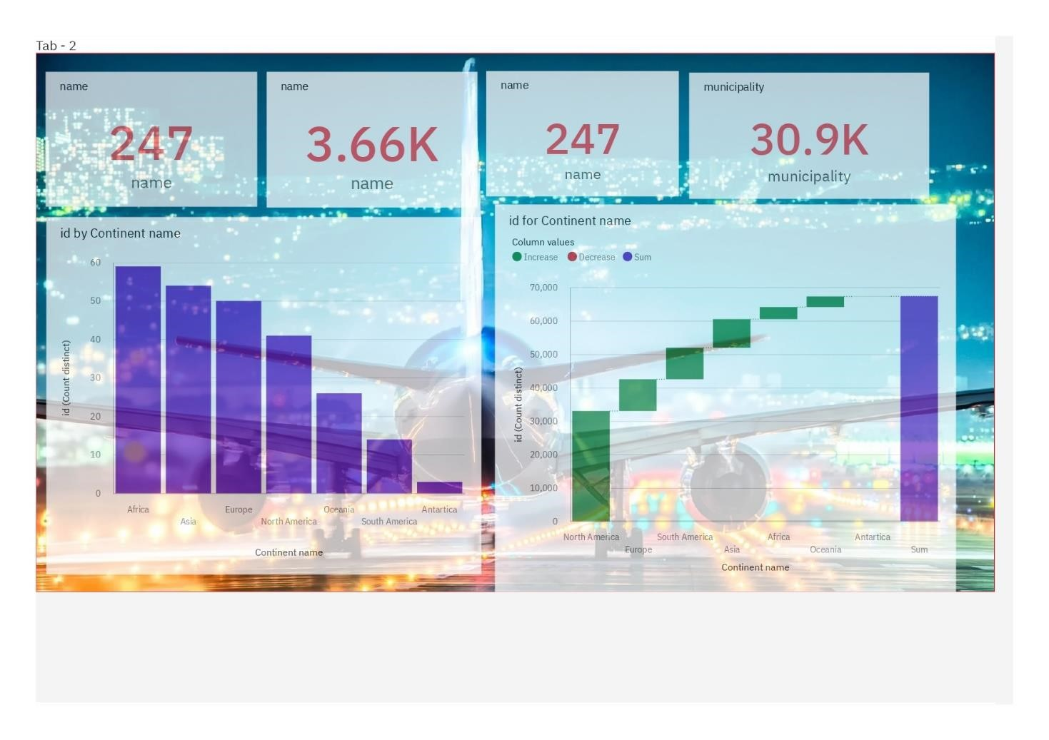

**Continent Wise Count Of Airports Using Geo Map :**

Geo-Map - Continent-wise No. of flights.

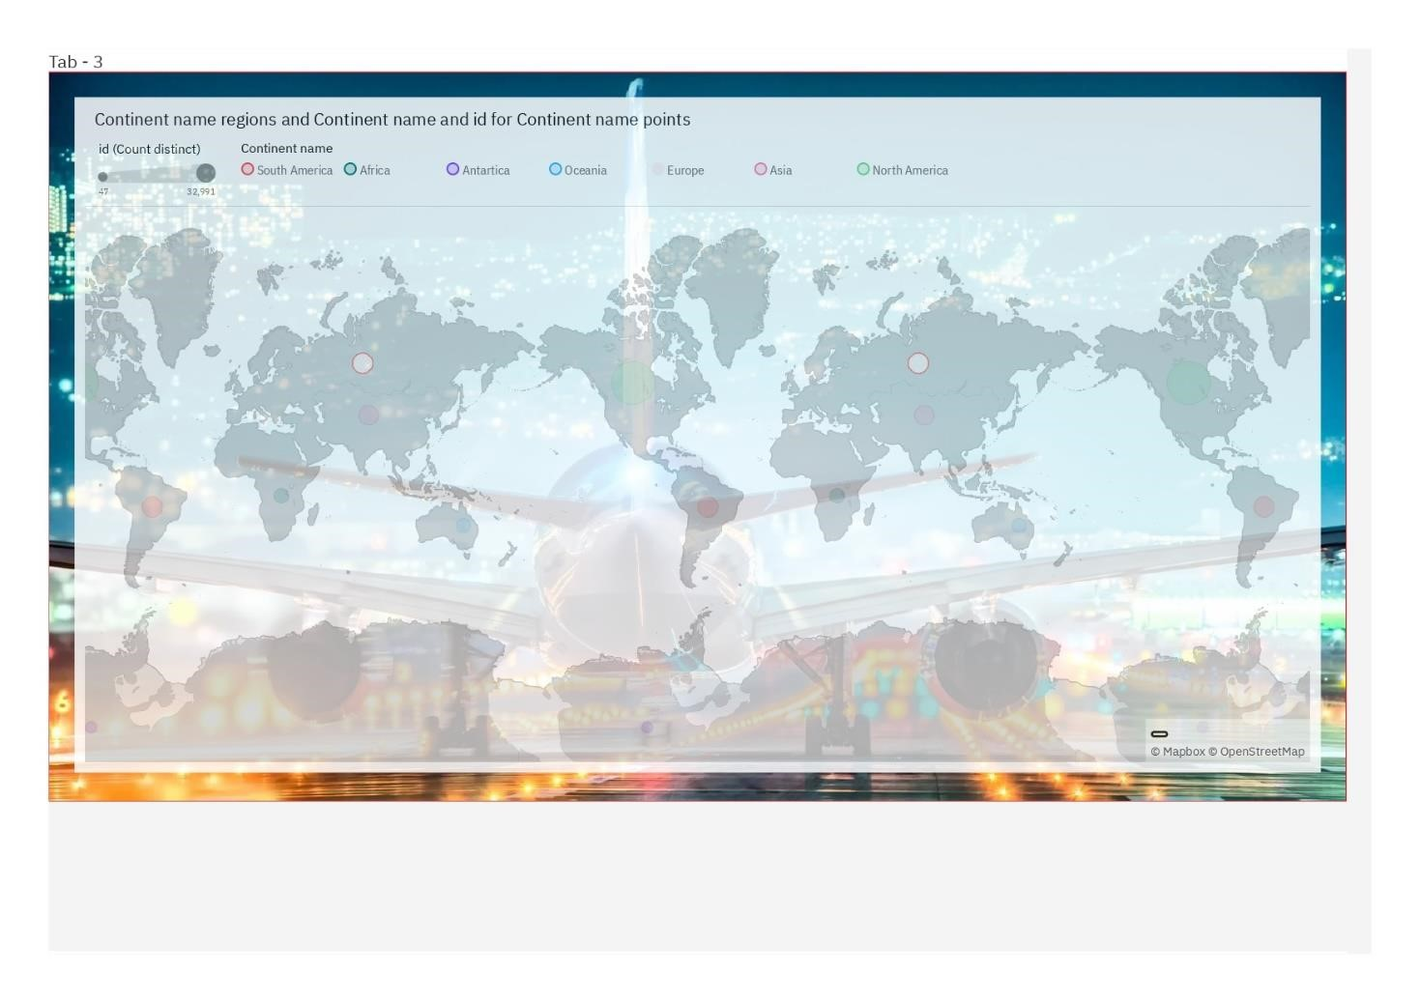

**Country Wise Airports With Types :**

1.Geo-Map - Country-wise No. of flights

2.Continent Filter

3.Flight-Type filter

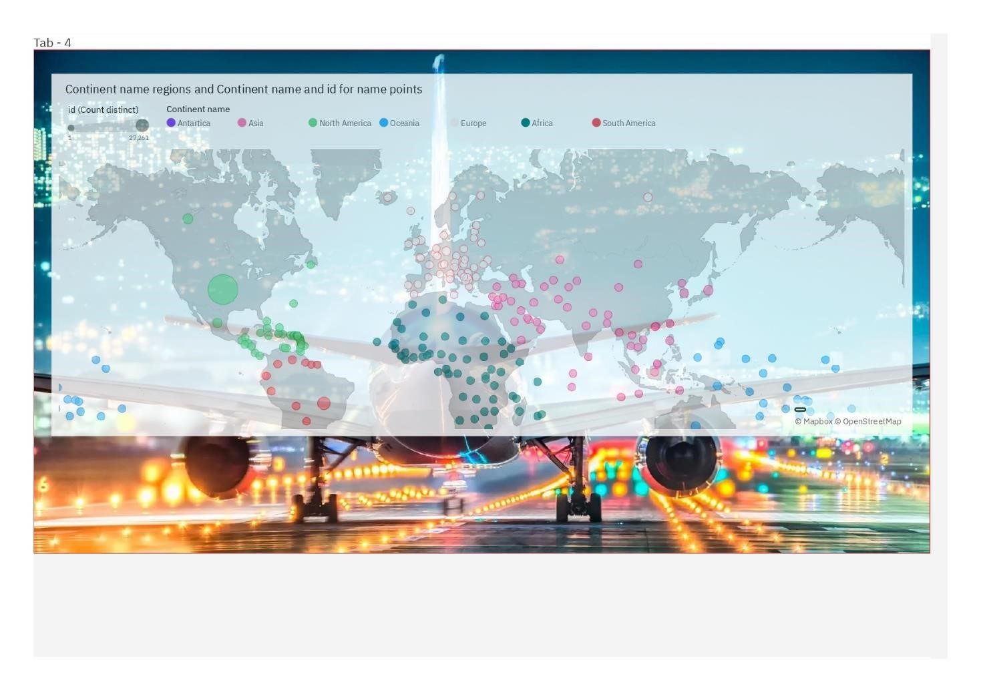

**Dashboard showing count of flights by Types,Countries and Continents:**

1. Column-Chart - No of Airports by Type
2. Hierarchy Bubble Chart - Region-wise Different Types of Airports
3. Packed bubble Chart - Municipality-wise No. of Airports
4. Bar Chart - Continent-wise No of Airports

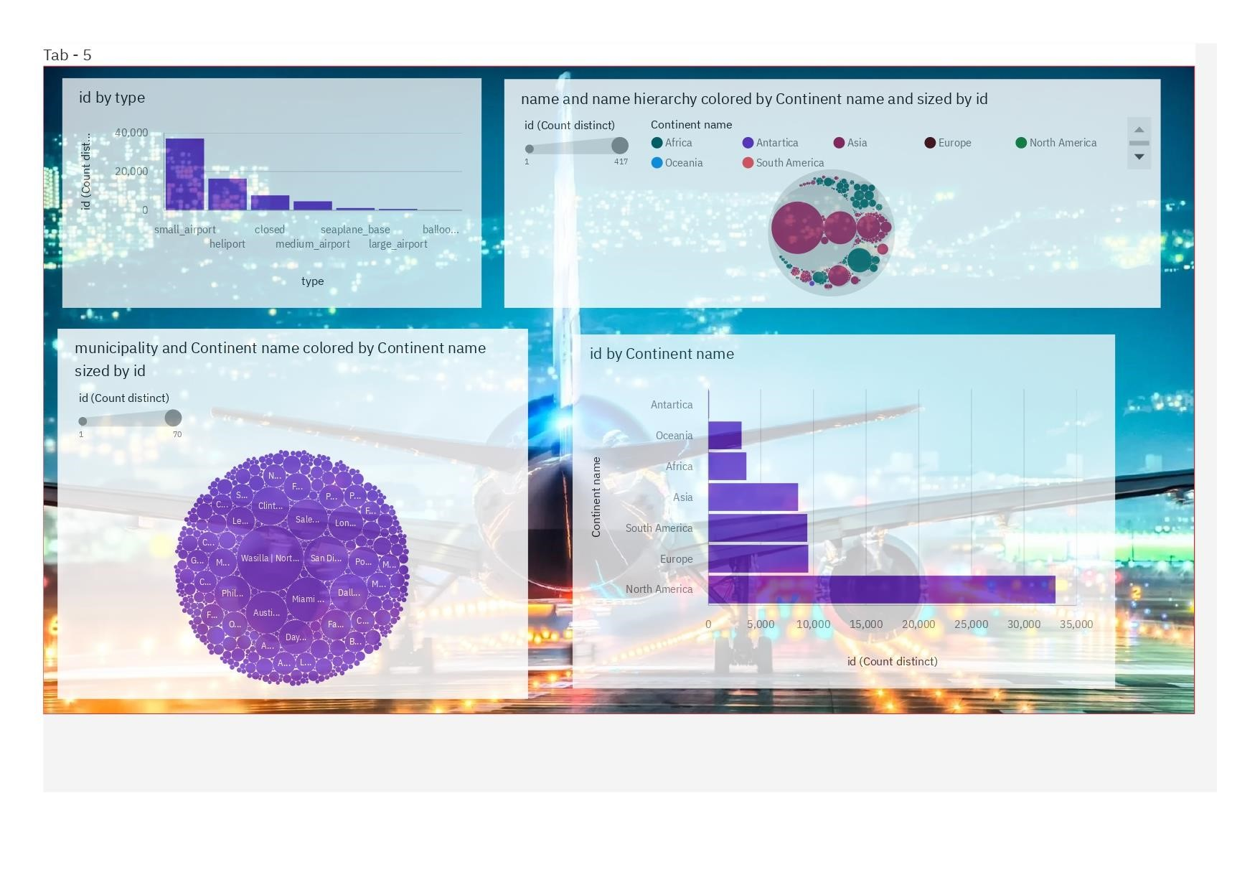

1. ,**TESTING :**

**8.1 Test Cases :**

|  |  |  |  |  |  |  |  |
| --- | --- | --- | --- | --- | --- | --- | --- |
| **Test case ID** | **Feature**  **Type** | **Component** | **Test Scenario** | **Steps To**  **Execute** | **Expected**  **Result** | **Actual**  **Result** | **Status** |
| LoginPage | Functional | Home | Verify | 1.Enter | Login/Sig | Working | Pass |
| _TC_OO1 |  | Page | user is | URL and | nup | as |  |
|  |  |  | able to | click go | popup | expected |  |
|  |  |  | see the | 2.Click on | should |  |  |
|  |  |  | Login/Sign | My | display |  |  |
|  |  |  | up popup | Account |  |  |  |
|  |  |  | when | dropdown |  |  |  |
|  |  |  | user | button |  |  |  |
|  |  |  | clicked on | 3.Verify |  |  |  |
|  |  |  | My | login/Sing |  |  |  |
|  |  |  | account | up popup |  |  |  |
|  |  |  | button | displayed or not |  |  |  |
| LoginPage | UI | dashboa | verify | 1.Airstat | required | working | pass |
| _TC_OO2 |  | rd page | user is | dashboard | visualisat | as |  |
|  |  |  | able to | will be | ion will | expected |  |
|  |  |  | see | displayed. | be |  |  |
|  |  |  | airport | 2.Check if | display |  |  |
|  |  |  | report in | each tab | ed on |  |  |
|  |  |  | dashboa | can able to | the |  |  |
|  |  |  | rd page | access. | dashboa |  |  |
|  |  |  |  | 3.Click on the required dataset.  4.OBtain the report | rd |  |  |

**8.2 User Acceptance Testing :**

**Defect Analysis:**

This report shows the number of resolved or closed bugs at each severity level, and how they were resolved.

|  |  |  |  |  |  |
| --- | --- | --- | --- | --- | --- |
| **Resolution** | **Severity 1** | **Severity 2** | **Severity 3** | **Severity 4** | **Subtotal** |
| By Design | 10 | 4 | 2 | 3 | 20 |
| Duplicate | 1 | 0 | 3 | 0 | 4 |
| External | 2 | 3 | 0 | 1 | 6 |
| Fixed | 11 | 2 | 4 | 20 | 37 |
| Not Reproduced | 0 | 0 | 1 | 0 | 1 |
| Skipped | 0 | 0 | 1 | 1 | 2 |
| Won't Fix | 0 | 5 | 2 | 1 | 8 |
| Totals | 24 | 14 | 13 | 26 | 77 |

**Test Case Analysis :**

This report shows the number of test cases that have passed, failed, and untested

|  |  |  |  |  |
| --- | --- | --- | --- | --- |
| **Section** | **Total Cases** | **Not Tested** | **Fa il** | **Pa ss** |
| Print Engine | 7 | 0 | 0 | 7 |
| Client Application | 51 | 0 | 0 | 51 |
| Security | 2 | 0 | 0 | 2 |
| Outsource Shipping | 3 | 0 | 0 | 3 |
| Exception Reporting | 9 | 0 | 0 | 9 |
| Final Report Output | 4 | 0 | 0 | 4 |
| Version Control | 2 | 0 | 0 | 2 |

**9.RESULTS :**

**9.1PerforMetrics**

**Model Performance Testing:**

Project team shall fill the following information in model performance testing template.

|  |  |  |
| --- | --- | --- |
| **S.No.** | **Parameter** | **Screenshot / Values** |
| 1. | Dashboard design | No of Visulizations / Graphs - 18 |
| 2. | Data  Responsiveness | It shows the output when any of the dataset is selected. |
| 3. | Utilization of Data  Filters | Various filter methods were used to filter the dataset values like sort,top or bottom,format data etc.., |
| 4. | Effective User Story | No of tabs Added - 5 |
| 5. | Descriptive Reports | No of Visulizations / Graphs -18 |

**10.ADVANTAGES & DISADVANTAGES : advantages :**

* It improves the average turnaround time needed to cater to market trends

* Properly implemented data modules help flight operators bag more customers and profits

* Predictive analytics is the key to preparing for future crises and put a mitigation plan in place

* It helps businesses make data-backed and more informed policy decisions

* Not just sales and customer service, data analytics play a vital role in flight operations and maintenance too

**disadvantages :**

* Air transport is a costly service. Its operational costs are too high. Middle class and poor people can not affect its cash.
* Air transport is prone to accidents. A small mistake can be very dangerous for passengers. Hijacking of planes is easily possible.
* For creating aviation facilities, huge investments are required. The cost of aero planes, construction and maintenance of aerodromes and control mechanism needs a capital expenditure.

11.**CONCLUSION :**

Flight delays are a major problem in civil aviation. They incur direct and indirect costs, such as maintenance at the gate, extra fees forcrew, food service, and lodging. They also affect passenger satisfaction. Flight delay is inevitable and it plays an important role in both profits and losses of the airlines. An accurate estimation of flight delay is critical for airlines because the results can be applied to increasecustomer satisfaction and the incomes of airline agencies. So, the prediction and analysis of flight delays are of great significance to airlines,passengers, and airports. Predicting delays will help an airport to adjust resource allocations, quickly analyse the causes, and take measuresto reduce or eliminate delays. Therefore, It delivers a well-friendly graphical UI and gives a proper delay rate to the users.

**12 FUTURE SCOPE :**

To illustrate, airlines bear high costs due to delays and cancellations that include expenses on maintenance and compensations to travellers stuck in airports. With nearly 30 % of the total delay time caused by unplanned maintenance, predictive analytics applied to fleet technical support is a reasonable solution.

**13.APPENDIX :**

**Source Code:**

**Source code for Login Page:**

<!DOCTYPE html>

<html lang="en">

<head>

<meta charset="UTF-8">

<meta name="viewport" content="width=device-width, initial-scale=1.0">

<title>Login Form</title>

<link rel="stylesheet" href="style.css">

<link rel="stylesheet" href="C:\Users\PC\OneDrive\Desktop\style.css" />

</head>

<body>

<div class="wrapper">

<header>Login Form</header>

<form action="https://zesty-duckanoo-d543d0.netlify.app/"> <div class="field email">

<div class="input-area">

<input type="text" placeholder="Email Address">

<i class="icon fas fa-envelope"></i>

<i class="error error-icon fas fa-exclamation-

circle"></i>

</div>

<div class="error error-txt">Email can't be blank</div>

</div>

<div class="field password">

<div class="input-area">

<input type="password" placeholder="Password">

<i class="icon fas fa-lock"></i>

<i class="error error-icon fas fa-exclamation-

circle"></i>

</div>

<div class="error error-txt">Password can't be blank</div>

</div>

<div class="pass-txt"><a href="#">Forgot password?</a></div>

<input type="submit" value="Login">

</form>

<div class="sign-txt">Not yet member? <a href="#">Signup now</a></div>

</div>

<script src="script.js"></script>

</body>

</html>

**Source code for Dashboard page:**

<!DOCTYPE html>

<html lang="en">

<head>

<meta charset="utf-8">

<meta content="width=device-width, initial-scale=1.0" name="viewport">

<title>AIRSTATS DASHBOARD</title>

<meta content="" name="description">

<meta content="" name="keywords">

<!-- Favicons -->

<link href="assets/img/favicon.png" rel="icon">

<link href="assets/img/apple-touch-icon.png" rel="apple-touch-icon">

<!-- Google Fonts -->

<link href="https://fonts.googleapis.com/css?family=Open+Sans:300,300i,400,400i,600

,600i,700,700i|Montserrat:300,400,500,700" rel="stylesheet">

<!-- Vendor CSS Files -->

<link href="assets/vendor/aos/aos.css" rel="stylesheet">

<link href="assets/vendor/bootstrap/css/bootstrap.min.css" rel="stylesheet">

<link href="assets/vendor/bootstrap-icons/bootstrap-icons.css" rel="stylesheet">

<link href="assets/vendor/glightbox/css/glightbox.min.css"

rel="stylesheet">

<link href="assets/vendor/swiper/swiper-bundle.min.css" rel="stylesheet">

<!-- Template Main CSS File -->

<link href="assets/css/style.css" rel="stylesheet">

<!-- =======================================================

* Template Name: NewBiz - v4.9.1
* Template URL: https://bootstrapmade.com/newbiz-bootstrap-business- template/
* Author: BootstrapMade.com
* License: https://bootstrapmade.com/license/

======================================================== -->

</head>

<body>

<!-- ======= Header ======= -->

<header id="header" class="fixed-top d-flex align-items-center">

<div class="container d-flex justify-content-between">

<div class="logo">

<!-- Uncomment below if you prefer to use an text logo -->

<h1><a href="index.html">Airlines Data Analytics for Avaition Industry</a></h1>

</div>

<nav id="navbar" class="navbar">

<ul>

<li><a class="nav-link scrollto active" href="#hero">Home</a></li>

<li><a class="nav-link scrollto"

href="#services">Dashboard</a></li>

<li><a class="nav-link scrollto" href="#contact">Contact</a></li>

</ul>

<i class="bi bi-list mobile-nav-toggle"></i>

</nav><!-- .navbar -->

</div>

</header><!-- #header -->

<!-- ======= Hero Section ======= -->

<section id="hero" class="clearfix">

<div class="container" data-aos="fade-up">

<div class="hero-img" data-aos="zoom-out" data-aos-delay="200">

<img src="assets/img/hero-img.svg" alt="" class="img-fluid">

</div>

<div class="hero-info" data-aos="zoom-in" data-aos-delay="100">

<h2>AIRLINES<br><span>DATA ANALYTICS</span><br>FOR AVIATION INDUSTRY</h2>

<div>

<a href="#services" class="btn-services scrollto">View Dashboard</a> </div>

</div>

</div>

</section><!-- End Hero Section -->

<main id="main">

<!-- ======= Services Section ======= -->

<section id="services" class="section-bg">

<div class="container" data-aos="fade-up">

<header class="section-header">

<h3>AIRSTATS ANALYSIS DASHBOARD</h3>

<iframe

src="https://us3.ca.analytics.ibm.com/bi/?perspective=dashboard&amp;pathRef=. my_folders%2FAIR%2BSTATS%2BDASHBOARD&amp;closeWindowOnLastView=true&amp;ui_ap pbar=false&amp;ui_navbar=false&amp;shareMode=embedded&amp;action=view&amp;mod e=dashboard&amp;subView=model0000018447f5966e_00000002" width="1300" height="1000" frameborder="0" gesture="media" allow="encrypted-media" allowfullscreen="">

</iframe>

</header>

</div>

</section><!-- End Services Section -->

<!-- ======= Contact Section ======= -->

<section id="contact">

<div class="container-fluid" data-aos="fade-up">

<div class="section-header">

<h3>Contact Us</h3>

</div>

<div class="row">

<div class="col-lg-6">

<div class="row">

<div class="col-md-5 info">

<i class="bi bi-geo-alt"></i>

<p>GCE TLY</p>

</div>

<div class="col-md-4 info">

<i class="bi bi-envelope"></i>

<p>https://github.com/capnpeace.com</p>

</div>

</div>

</div>

</div>

</section><!-- End Contact Section -->

</main>

<!-- End #main -->

<a href="#" class="back-to-top d-flex align-items-center justify-content- center"><i class="bi bi-arrow-up-short"></i></a>

<!-- Vendor JS Files -->

<script src="assets/vendor/purecounter/purecounter_vanilla.js"></script>

<script src="assets/vendor/aos/aos.js"></script>

|  |  |
| --- | --- |
| <script | src="assets/vendor/bootstrap/js/bootstrap.bundle.min.js"></script> |
| <script | src="assets/vendor/glightbox/js/glightbox.min.js"></script> |
| <script | src="assets/vendor/isotope-layout/isotope.pkgd.min.js"></script> |
| <script | src="assets/vendor/swiper/swiper-bundle.min.js"></script> |

<script src="assets/vendor/php-email-form/validate.js"></script>

<!-- Template Main JS File -->

<script src="assets/js/main.js"></script>

</body>

</html>

**Github** [**repositories :**](https://github.com/capnpeace?tab=repositories)

[**https://github.com/IBM-EPBL/IBM-Project-7765-1658898257.git**](https://github.com/IBM-EPBL/IBM-Project-7765-1658898257.git)